DATA 260 Homework 2 Report
Sreeram Achutuni
SJSU ID: 019151808

Section 0: Config values
SID4 | 1808
PORT_BASE | 8008
PREFIX | s1808
SEED | 1808
VERIFY_SEED | 261808
DOMAIN_ID | 0, Campus course catalogue and enrolment
Hardware | Intel Core i7-11390H, 16GB RAM, integrated Iris Xe graphics (no dedicated GPU)
Local model | qwen2.5:1.5b-instruct (Ollama), used instead of the qwen3:8b default since this laptop has no GPU and that model was too slow for the amount of runs this homework needed
Repo | https://github.com/sriram2930/Data260-1808
Commit tagged as hw2 | to be filled in once everything below is final and pushed

Part 1: HTML and CSS
The assignment wanted the HW1 course list and form to still be usable at a 375px screen width, and to have some visible loading, empty and error state instead of the page just doing nothing or breaking.
I checked the 375px width using Chrome dev tools (device toolbar, width set to 375). At that width everything stacks into one column and nothing gets cut off or needs horizontal scrolling, the search box and the course cards and the add form all still work normally.
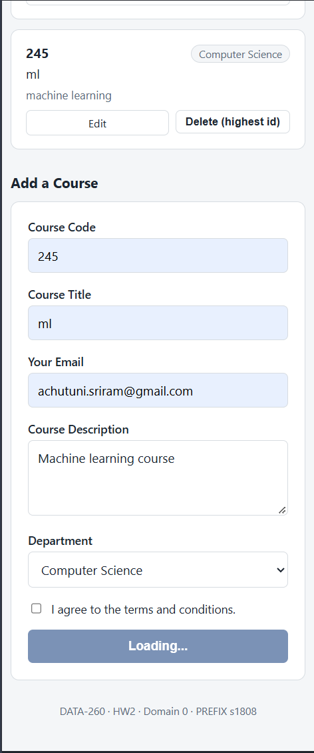
Home page at 375px width, before adding anything.
For the loading state I did not build anything with a real spinner talking to a database, since this app just keeps everything in memory. What I did instead is make the submit buttons switch their text to "Loading..." and disable themselves right when you click, before the redirect actually happens. It is a small thing but it is a real state change on the screen, not just a static page. Below is what it looks like mid submit while adding a course with code 245 and title ml:

Add form showing the Loading state right after clicking submit.
The empty state shows up when a search does not match any course. I typed "abcd" into the search box on purpose, since that is not part of any course code or title in the list, and got the "No courses match your search" message instead of a blank list:

Search with no matching results, empty state message shown.
The error state was supposed to be a red banner at the top telling you Course Code and Course Title are required. When I tested this earlier with curl it worked exactly like that. But when I actually tried it from the browser by leaving both fields blank and clicking submit, the browser itself blocked the submit with its own little tooltip ("Please fill out this field") because I still had the required attribute on those two inputs in the HTML. So my banner never even got a chance to show up here, the browser caught it first. I am leaving this in as is instead of quietly fixing it, since it is a real thing I found while testing rather than something I planned:
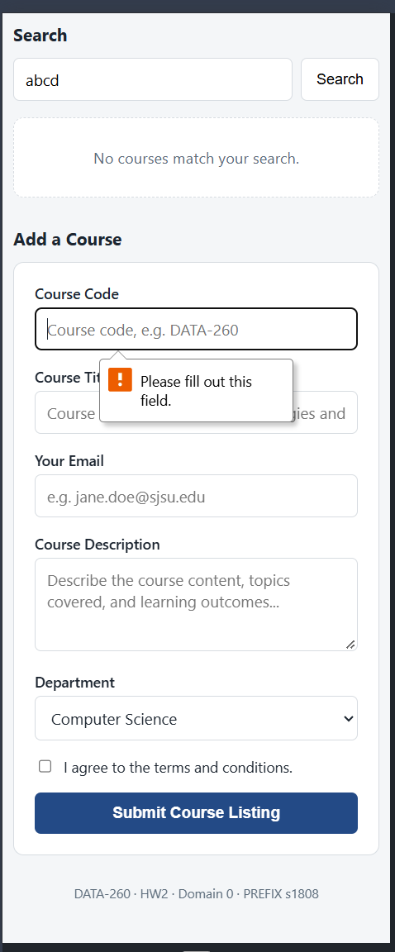
Trying to submit with blank required fields, browser's own validation kicks in first.

Relevant CSS
The card layout rules:
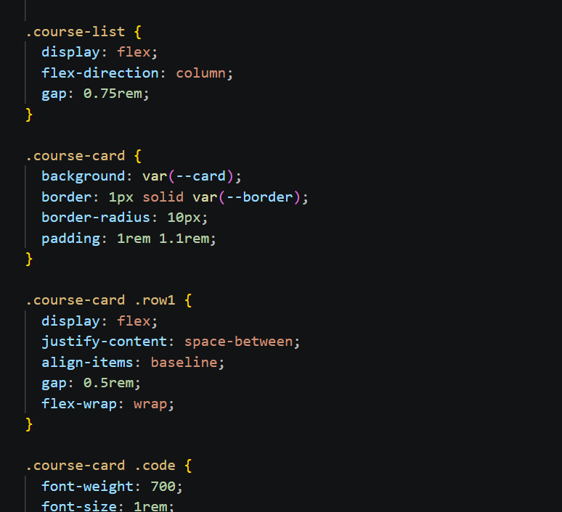
More card rules, for the department pill, title, description and action buttons:
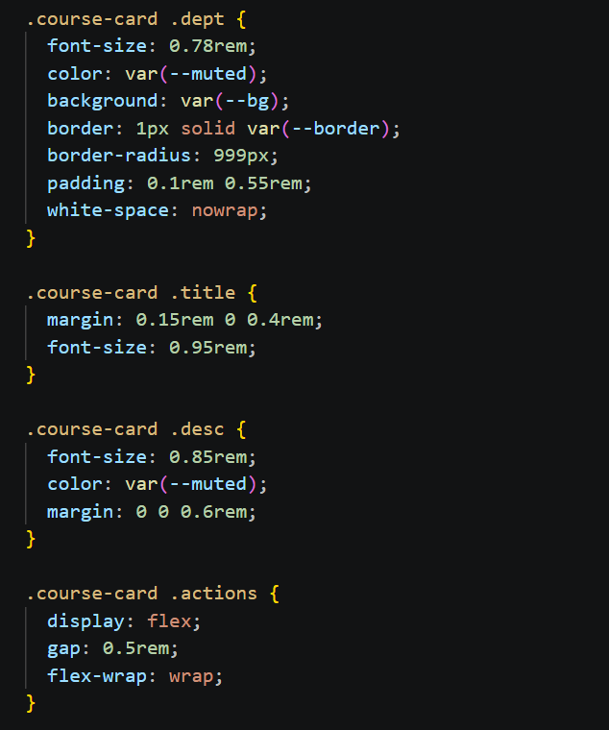
The empty and error placeholder styling, plus the loading spinner:
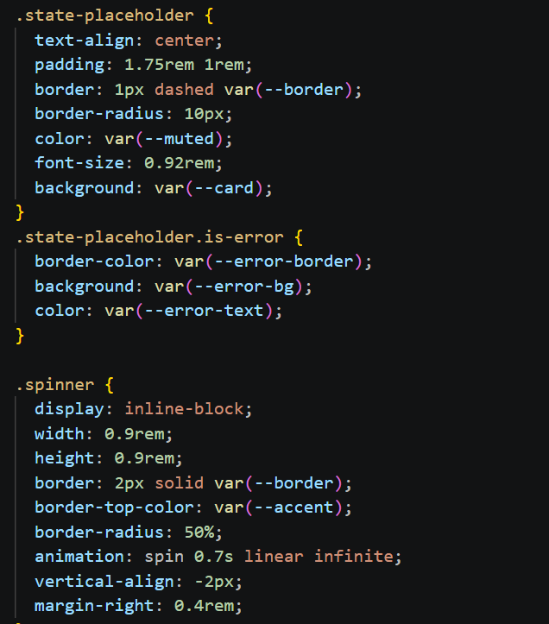
And the actual responsive rule, the part that matters most for the 375px question, is this media query near the bottom of the stylesheet:
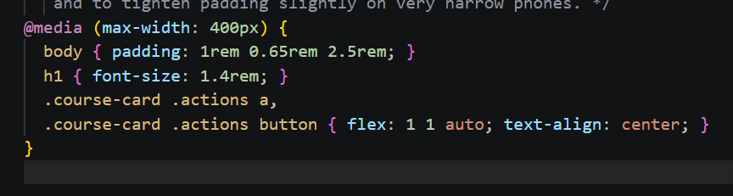

Part 2: FastAPI backend
This is the backend behind the form. Adding, updating and deleting all go through normal HTML form submits that redirect back to the home page afterward (a 303 redirect), not through JavaScript fetch calls. Search is the one exception, that one does use fetch so the list can update without reloading the whole page.
To test adding a course I filled in Course Code as "DATA 260" and Course Title as "AGENTIC AI" and left everything else blank on purpose, just to see if it would still go through with only those two filled in:
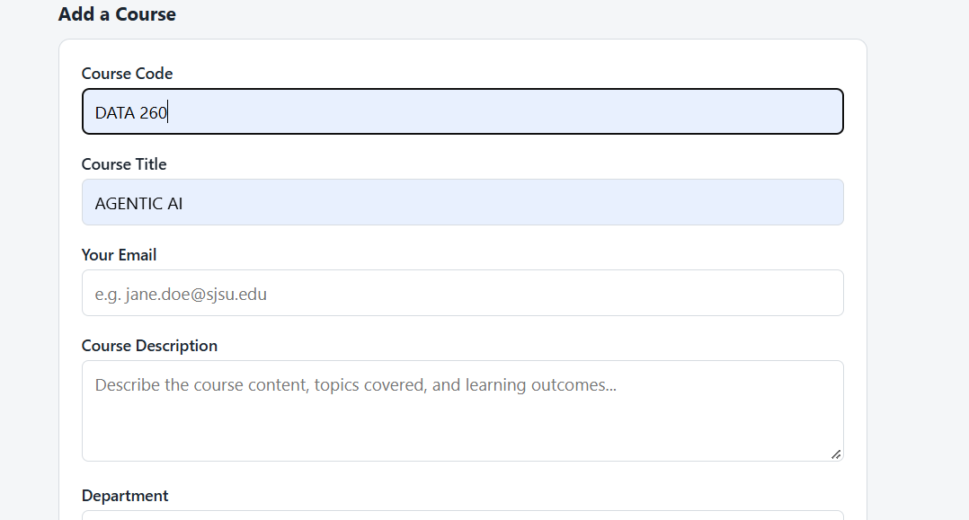
Add form filled in with a new course code and title.
After submitting, it shows up at the bottom of the list, filed under Computer Science since I never touched the department dropdown:
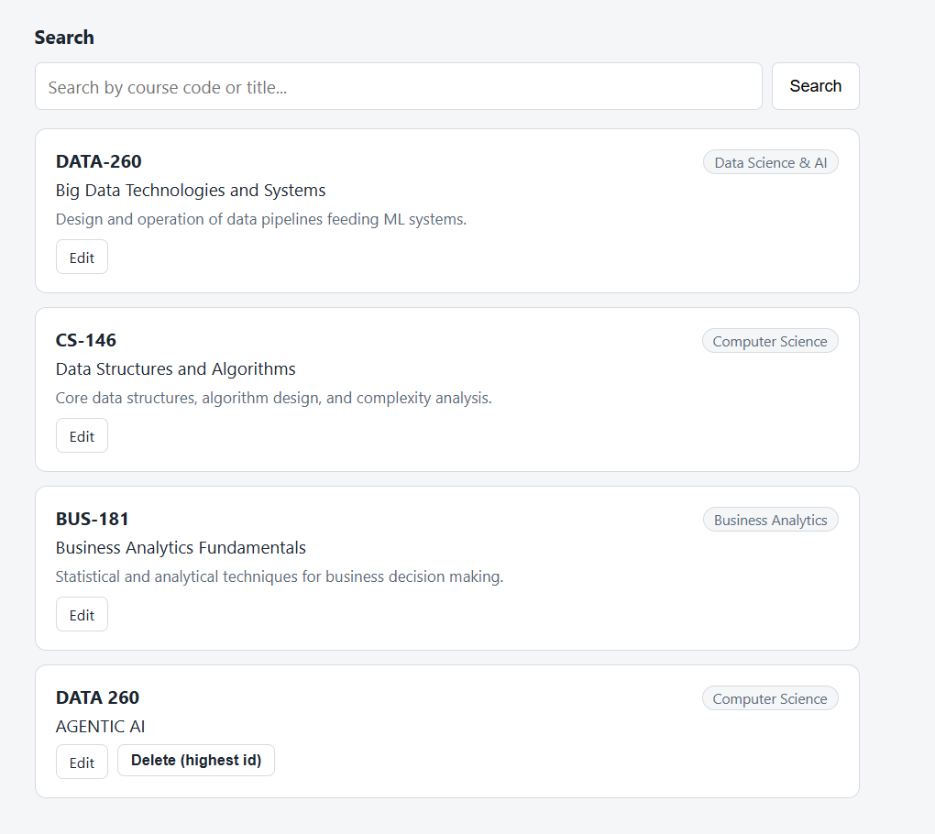
Home page after the add, new course now in the list.
I then added a second, similar course (title "AGENTIC AI and Distributed systems") just so there would be a 5th record and the highest id delete button would have something obvious to remove:

List with a 5th record added, Delete (highest id) button now showing on it.
Clicking that Delete button removes the highest id record and drops you back on the home page with a small confirmation banner:

After deleting course #5, back to 4 records, confirmation banner visible.
Search for "data" pulls in DATA-260 and the DATA 260 I added, plus CS-146 too, since "Data Structures" is in that course's title. So it is matching on both the course code and the title field, not just one of them:
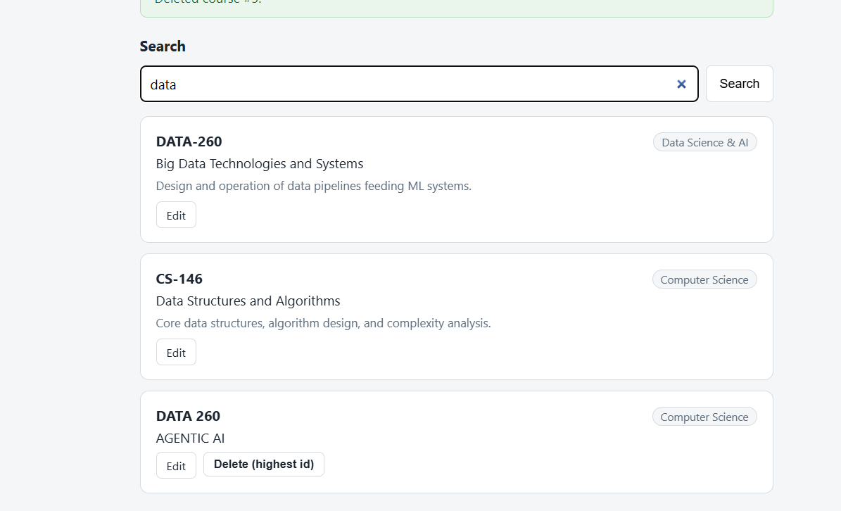
Search results for the query 'data'..

Relevant backend code
Adding a course:
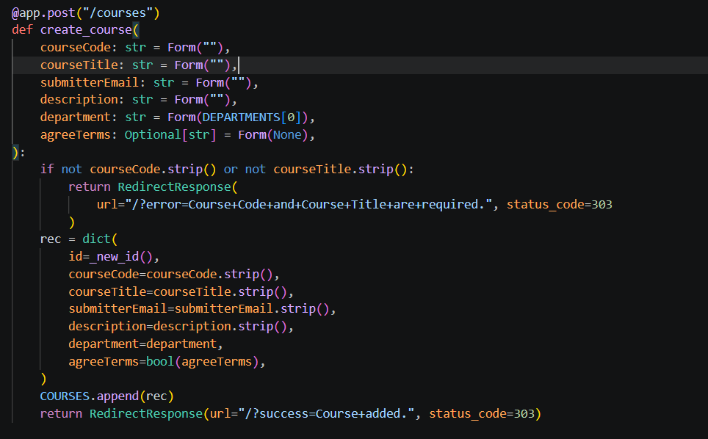
Loading the edit form for one record:
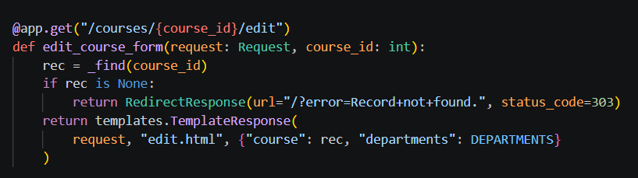
Updating a record by id, this is the route that is meant to update id 1:
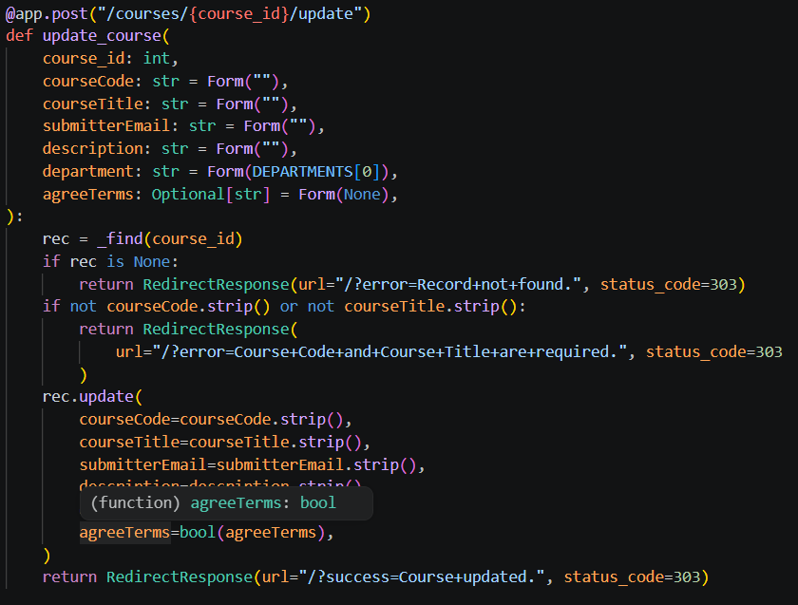
Deleting the highest id record, and the app entry point:
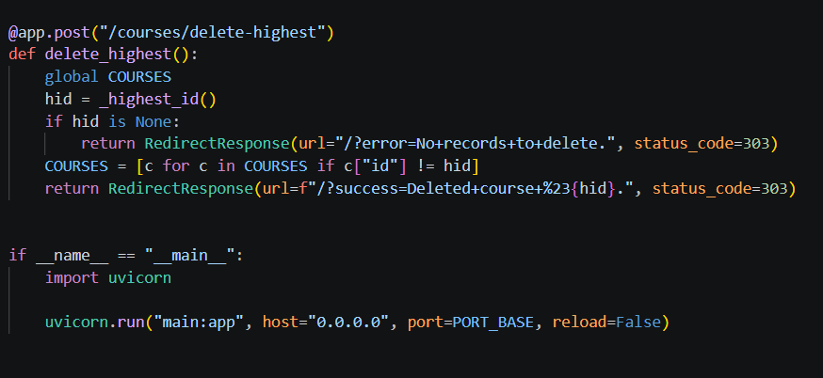
The JSON endpoint the search box's fetch call hits:
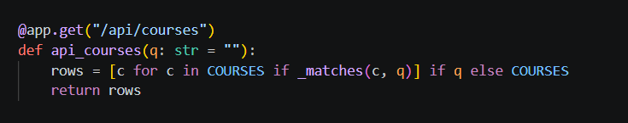

Part 3: Stateful agent graph
This part takes the Planner and Reviewer from HW1 and puts them into an actual LangGraph graph instead of just calling one function after another. There is a Supervisor node that does not do any of the actual work itself, it just sits between Planner and Reviewer and a routing function decides where to go next based on whether there is a proposal yet, whether it passed validation, and whether the Reviewer approved it.
A normal run looks like this, Planner produces something, Reviewer approves it on the first try, done:
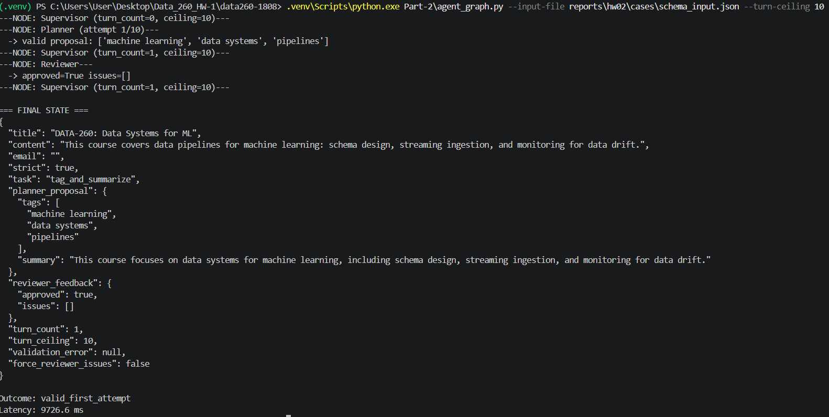
Normal run, approved on the first Planner attempt.
To actually prove the correction loop works and is not just theoretical, I ran it again with a flag that forces the Reviewer to reject no matter what, so I could watch it send the task back to the Planner instead of just trusting that the code would do that if it needed to:
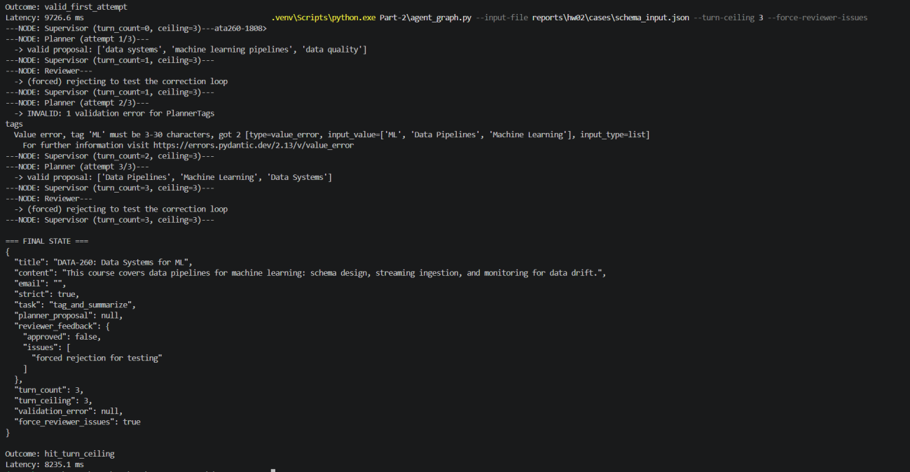
Reviewer forced to always reject, graph keeps looping back to the Planner until the turn ceiling is hit.

The state and the nodes
The shared state every node reads from and writes back to:
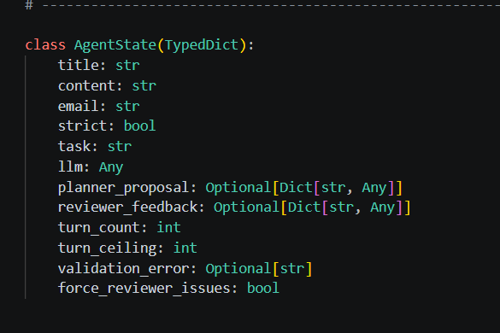
The Planner node. It builds the prompt, adds on whatever went wrong last time (either a validation error or a Reviewer rejection) so the model has something concrete to fix, then tries to parse and validate the response:
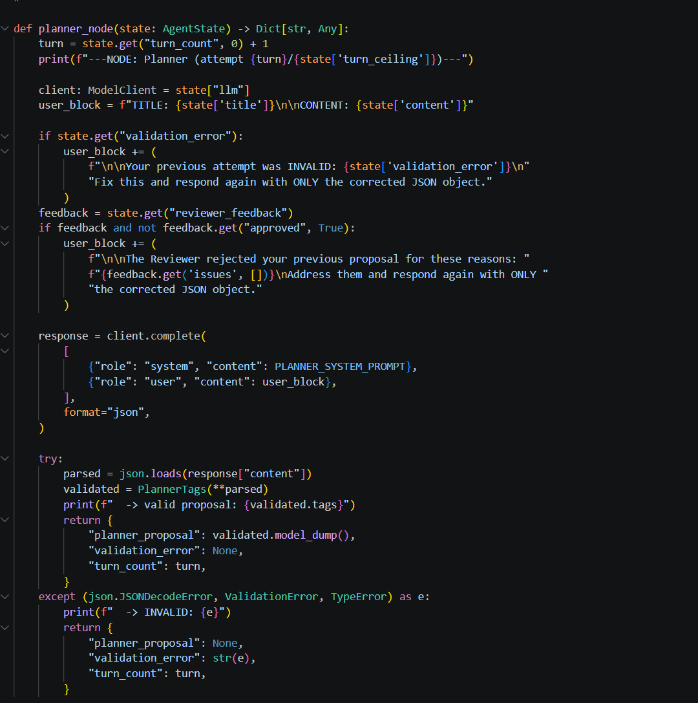
The Reviewer node, plus the forced rejection test hook mentioned above:
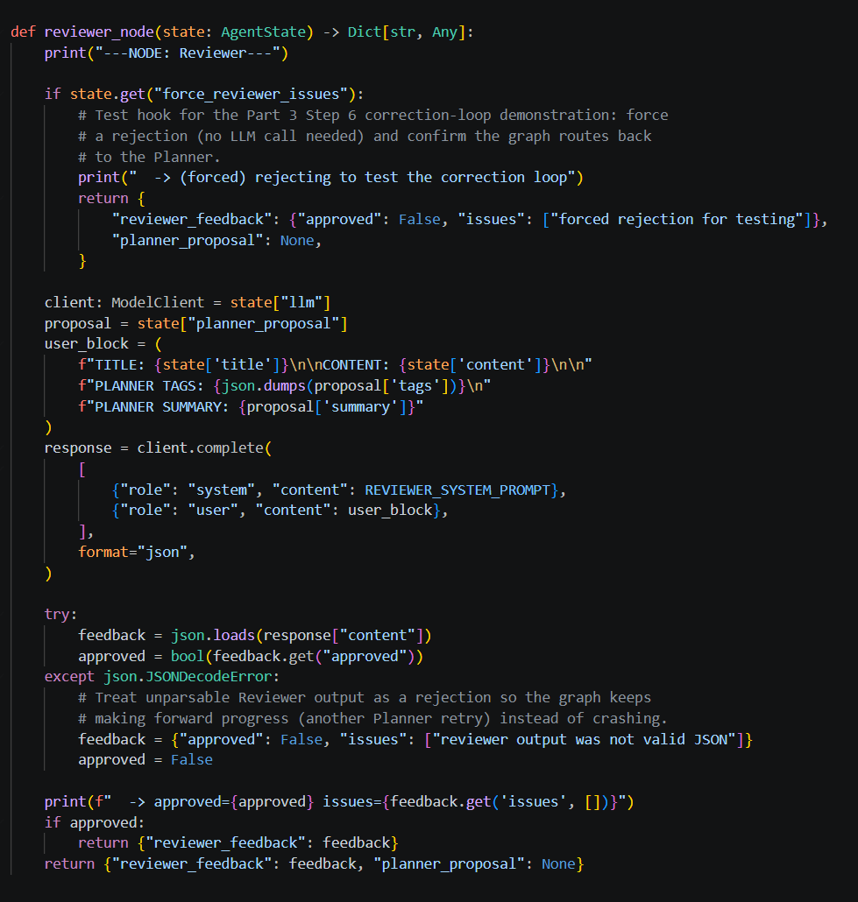
The Supervisor node, which mostly just exists to sit in between the other two and print where things are:
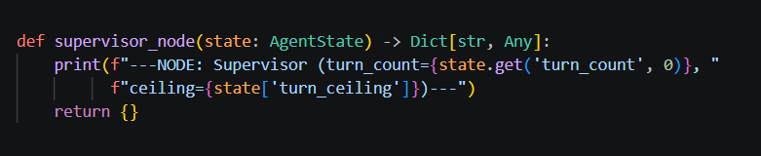

Part 4: Output schema and loop safety
The routing function that actually decides planner vs reviewer vs stop:
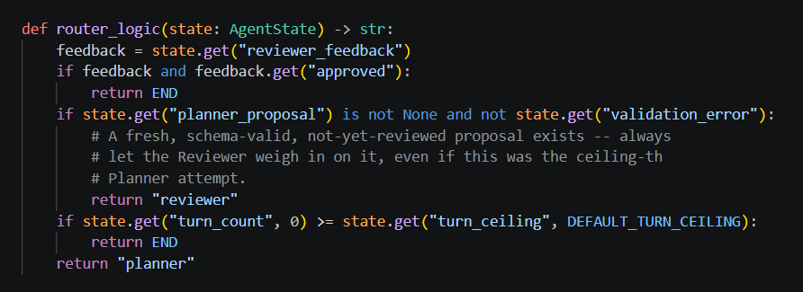
Below is one of the runs from the 30 run experiment. This particular one needed a few retries, the Reviewer rejected the first valid proposal for being too vague, then a couple of attempts failed the tag validation entirely (wrong number of tags in the list), before it eventually landed on something both schema valid and Reviewer approved:
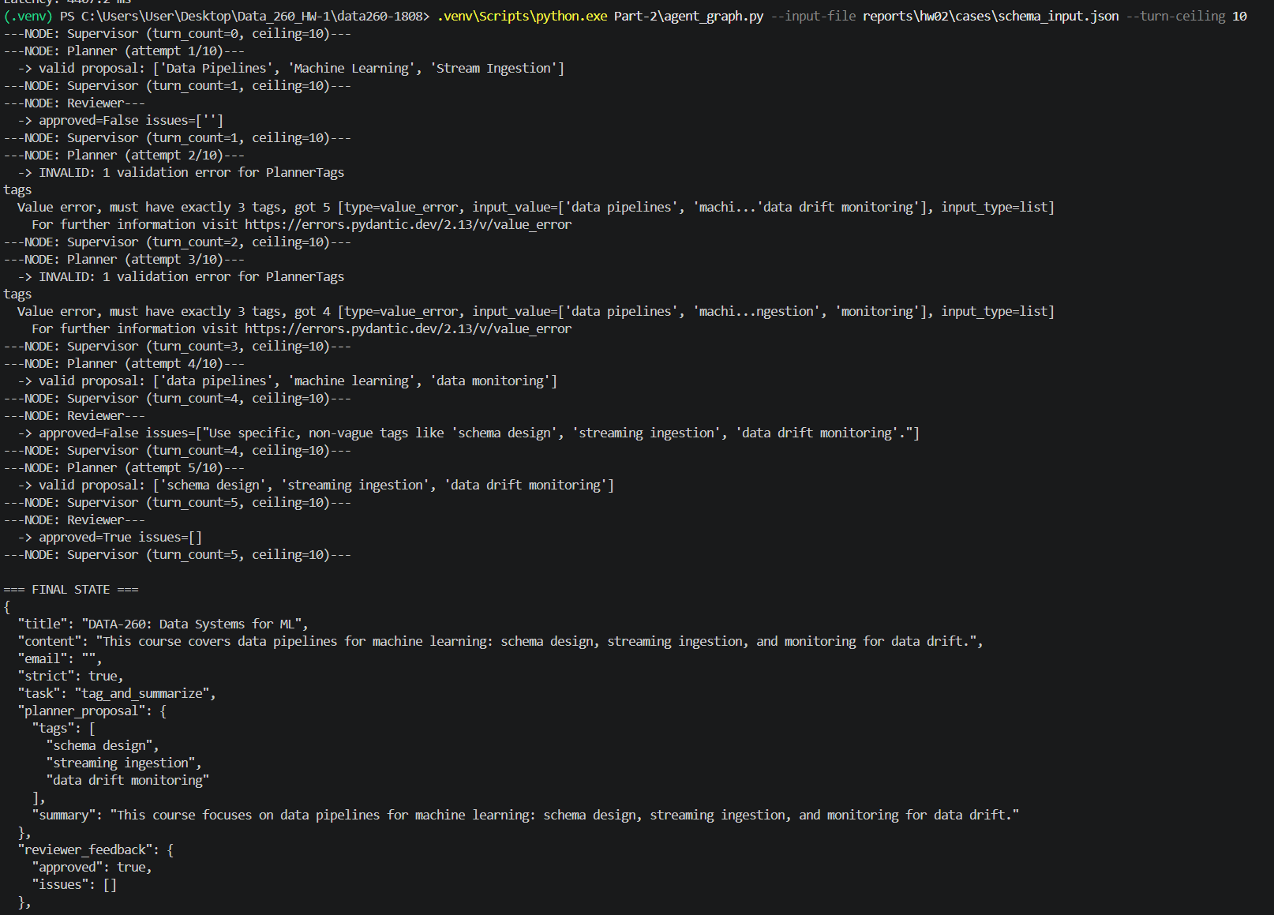
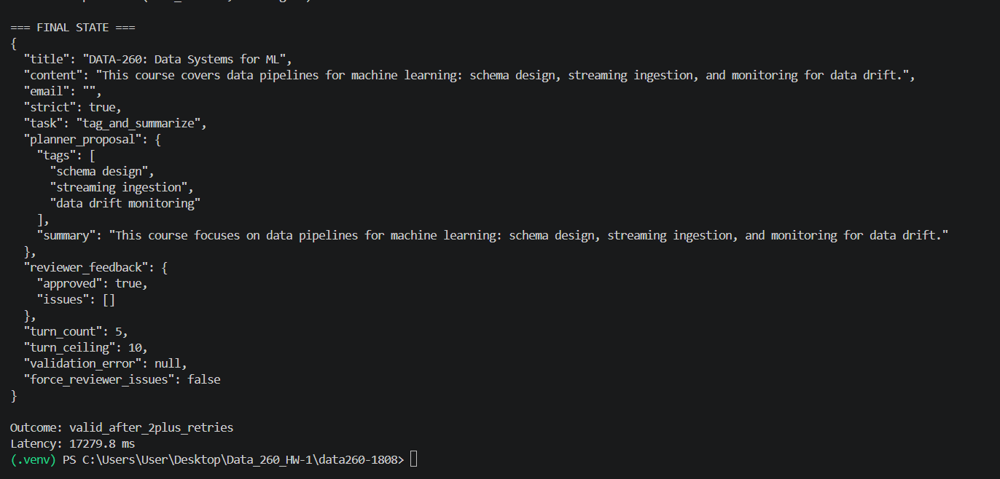
One run from the classification experiment, ends up in the valid_after_2plus_retries bucket.
And the summary block after all 75 runs (30 for classification, 20 plus 20 for the ceiling comparison, 5 adversarial):
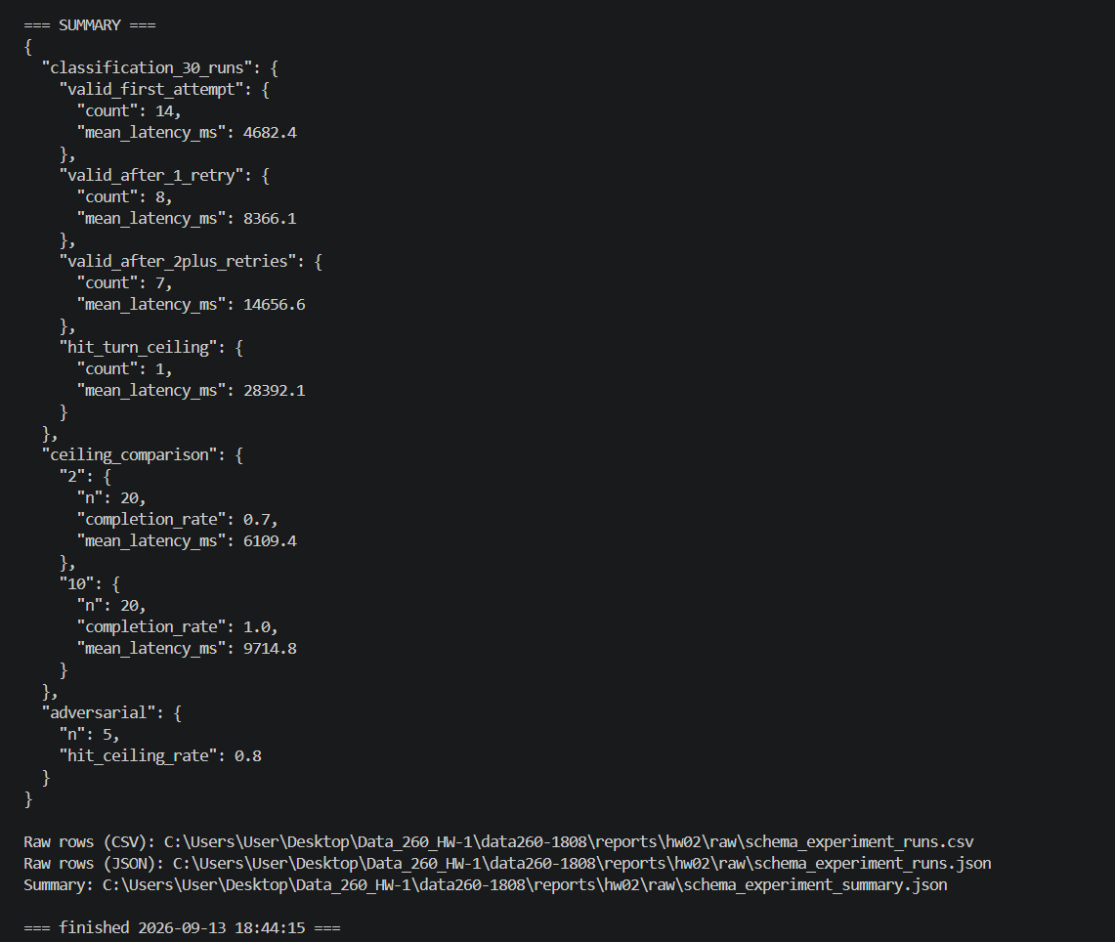
Final summary printed after the full experiment script finished.

Results
Outcome over 30 runs | Count | Mean latency (ms)
Valid first attempt | 14 | 4682.4
Valid after 1 retry | 8 | 8366.1
Valid after 2+ retries | 7 | 14656.6
Hit turn ceiling | 1 | 28392.1

Turn ceiling | Completion rate | Mean latency (ms)
2 | 70% | 6109.4
10 | 100% | 9714.8
Between the two, I would go with a turn ceiling of 10 for anything real. Ceiling 2 finishes about 3.6 seconds faster on average, but it also fails to ever get an approved answer 30% of the time, which is a pretty rough failure rate for something a user is actually waiting on. Ceiling 10 costs more time on average but got every single run to a valid, approved result.

Adversarial input
For the adversarial case I reused the longer, denser course description from HW1 (the one with schema design, batch and streaming ingestion, feature stores, versioning, drift monitoring, all packed into one paragraph). Running it 5 times, it hit the turn ceiling 4 out of 5 times.
My best guess for why: there is just too much going on in that description for a 25 word summary to cover, so the model keeps writing a longer summary that covers more of it instead of a short one, even after being told exactly how many words over it was. It is not that the model cannot count to 25, it seems more like it is choosing to keep the content over following the limit. A fix I would try if I had more time is not just repeating the word count error back to it, but telling it something more mechanical like "cut this down to one clause" or giving it a hard example of the right length, since just repeating the number does not seem to be enough on its own.

